**Creating Amazon Clone in** React

1. Install npx

Npm install -g npx

1. Change directory to the app directory

Cd amazon-clone

1. Create the app

Npx create-react-app amazon-clone

1. Setup Firebase

Login to Google Firebase with your google account

Create a new project.

Take a note of Config

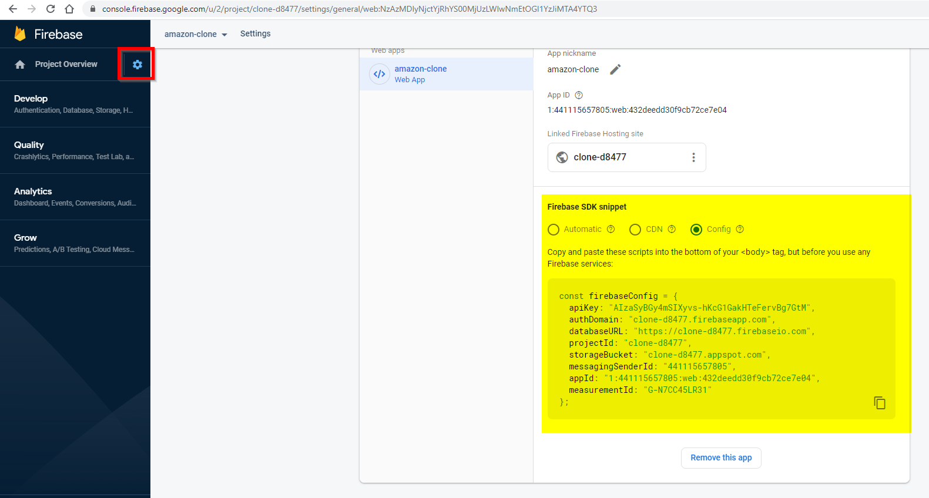

1. Install firebase tools to the project

npm install -g firebase-tools

1. Start the app the check if it’s running on localhost:3000

Npm start

1. Cleanup few files from the template project that is created.

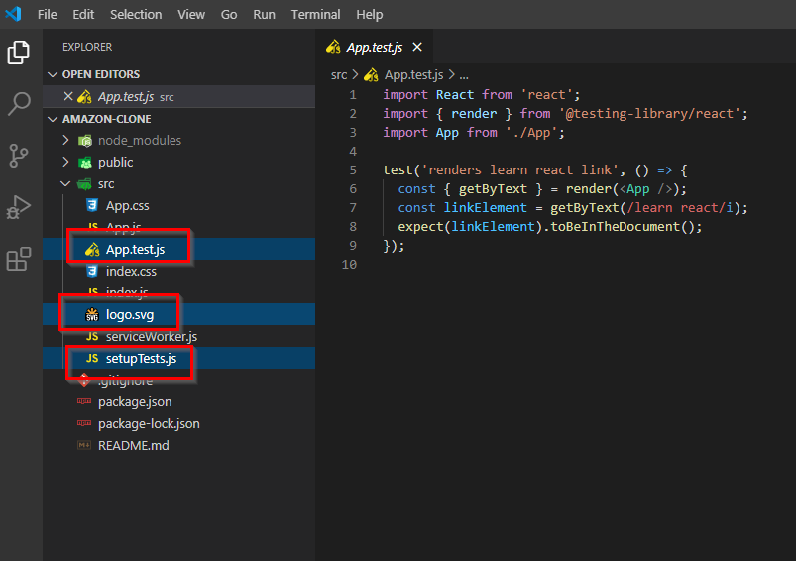

1. Setup React-Router

Npm install react-router-dom

1. Import BrowserRouter, Switch and Route

import {BrowserRouter as Router, Switch, Route } from "react-router-dom";

Router is need to switch between different pages without posting it to the server thus giving a seamless user experience.

Switch is just like a CASE statement in any programming language.

* Quick Tip: Install extension ES7 for auto code snippets. Example: rfce to load React Functional Component.
* <https://material-ui.com/> for icons like font awesome.
* For typing emojies enter extension emojisense. Modify the settings.json as per the comments.
* VSCode 🡪 Ctrl + / - Comment text
* Margin vs Padding: Margin get appended to the outside of the element but Padding is applied to the inside of/within the element.
* Collaborative whiteboarding tool. [https://awwapp.com/#](https://awwapp.com/) || <https://aggie.io/>
* …state 🡪 where … is the spread attribute.

1. Install material-ui icons. Core and incons.

npm install @material-ui/core

npm install @material-ui/icons

1. Authentication in Firebase

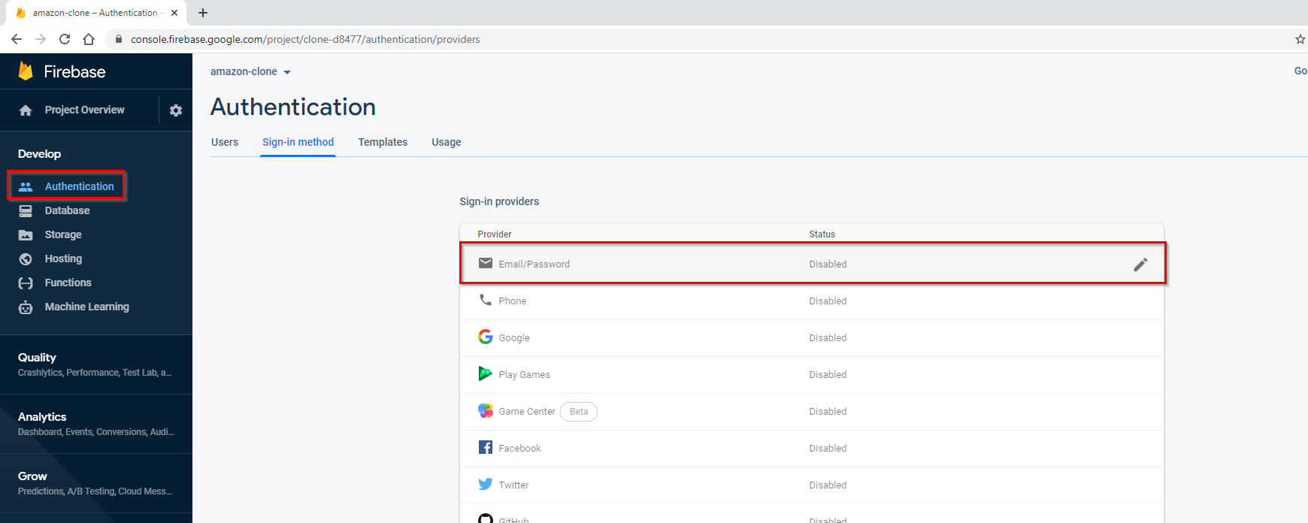

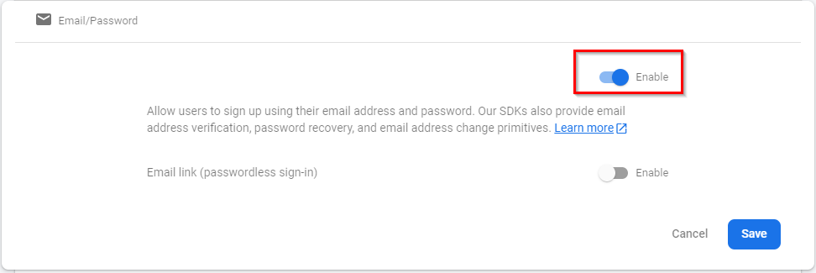

1. Deploying the app in Firebase

From terminal 🡪 firebase login

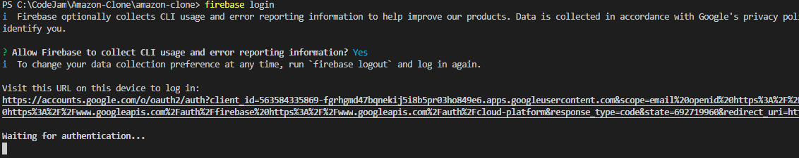

This will take you to the google firebase login authentication page.

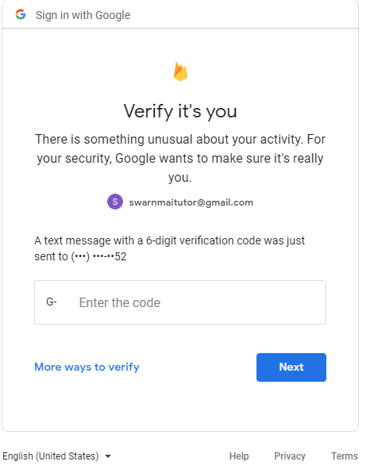

Upon entering the code you will get successful message from Google

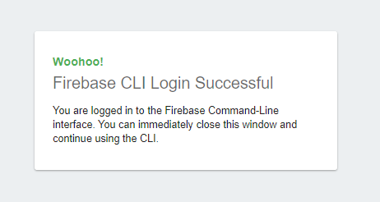

And success message in the terminal



Next enter firebase init

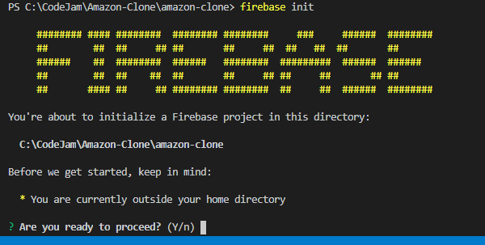

Make sure you are in the current application directory. Enter Y.

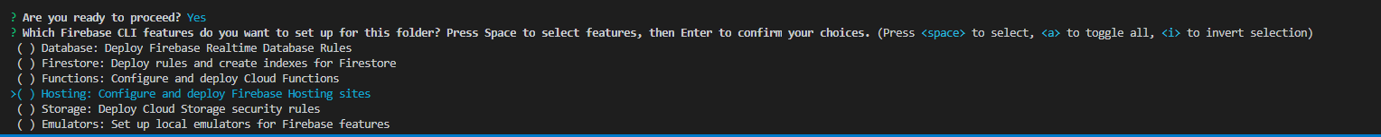

Select Hosting and hit space bar to select.

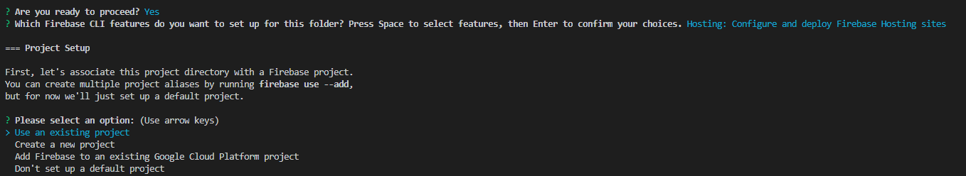

Use an existing project.

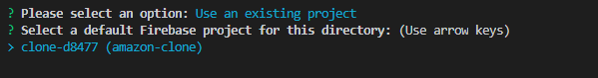

Select the project from the list of projects. Here I have only one project created in Firebase.

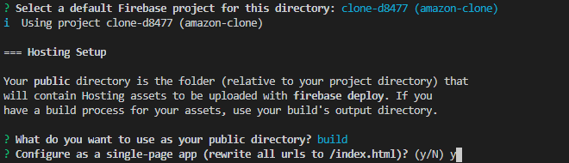

Enter “build” and “y”

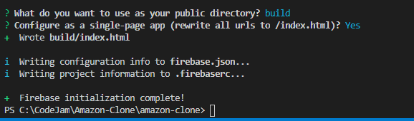

Next Build the application and deploy

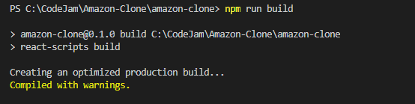

npm run build

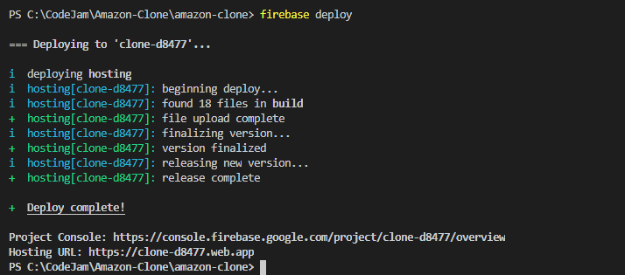

Firebase deploy